Setup Object Detection on your PC

Step 1: Install Git.
Go to https://git-scm.com/, and download the latest version of Git and install.
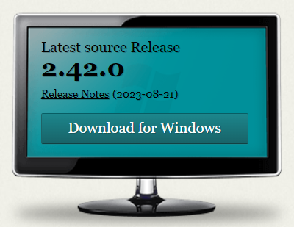

Step 2: Download the project repository to the local PC.
Open your command prompt, and clone the project repository to your local drive: git clone https://github.com/liuzheng1990/object_detection.git

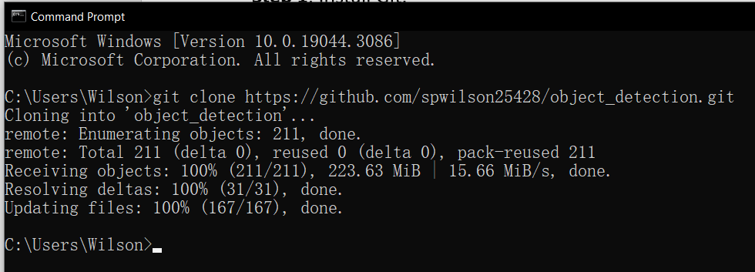

Step 3: Create virtual environment for the project.

Inside the command prompt, we can create a new virtual environment by typing: conda create --name yolo_env python=3.8
(Note: If using command prompt does not work, then try using the Anaconda prompt instead.)
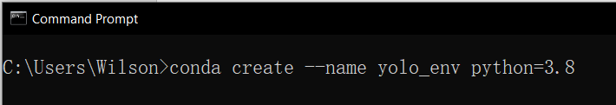
After creating the virtual environment, we can activate the virtual environment by typing: conda activate yolo_env

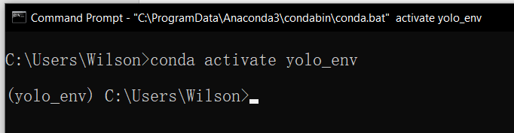

Step 4: Install necessary libraries
Change the directory to the object_detection folder, and install all the necessary libraries: pip install -r requirements.txt

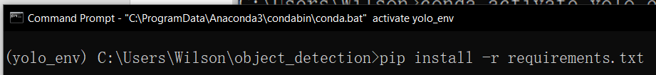

Step 5: Start to run the object detection model

You can now start the object detection model:
python detect.py --source 0 --nosave

Change the source value to 0 or 1 to use the Logitech camera.
If too many objects are detected, consider setting a higher threshold by:
python detect.py --source 0 --nosave --conf-thres 0.6
(Change the threshold to higher -> 0.7 if needed)

